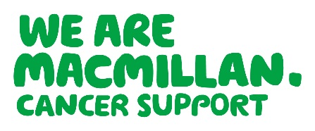
North Central & North-East London Practice Nurse Cancer Care Course

A free 5-day course delivered by Macmillan GP’s and The Royal Marsden
This course is specifically designed for Practice Nurses

The Modules Cover:

- Prevention, early detection, treatment & palliative care
- The changing story of cancer
- The Recovery Package
- The impact of cancer
- Communicating with people affected by cancer

The Course Objectives are to:

- Increase Practice Nurse ability to undertake Cancer Care Reviews
- Increase understanding of the changing cancer pathway
- Improve understanding about the consequences of living with cancer
- Improve confidence in sign posting cancer patients to resources & services

What Practice Nurses said about this course:
I will be better able to discuss cancer with my patients
Excellent course – Very interesting & informative which has filled a gap in our Practice Nurse training

Excellent course, must be done by every nurse working in Primary Care
Very good course to help me support and help my patients

Inspirational!
Excellent speakers

Venue: The Royal Marsden School, Fulham Road, London, SW3 6JJ
Dates: 14/03/2018 | 11/04/2018 | 02/05/2018 | 06/06/2018 | 20/06/2018

For further information contact Julie Latimer: jlatimer@macmillan.org.uk or 07834 192 232

To book a place please contact LondonSELearning@macmillan.org.uk

